**Project Design Phase-II**

**Data Flow Diagram & User Stories**

|  |  |
| --- | --- |
| Date | 03 October 2022 |
| Team ID | PNT2022TMID24857 |
| Project Name | Project - Real-Time Communication System Powered by AI for Specially Abled |
| Maximum Marks | 4 Marks |

**Data Flow Diagrams:**

A Data Flow Diagram (DFD) is a traditional visual representation of the information flows within a system. A neat and clear DFD can depict the right amount of the system requirement graphically. It shows how data enters and leaves the system, what changes the information, and where data is stored.

**DFD Level 0**

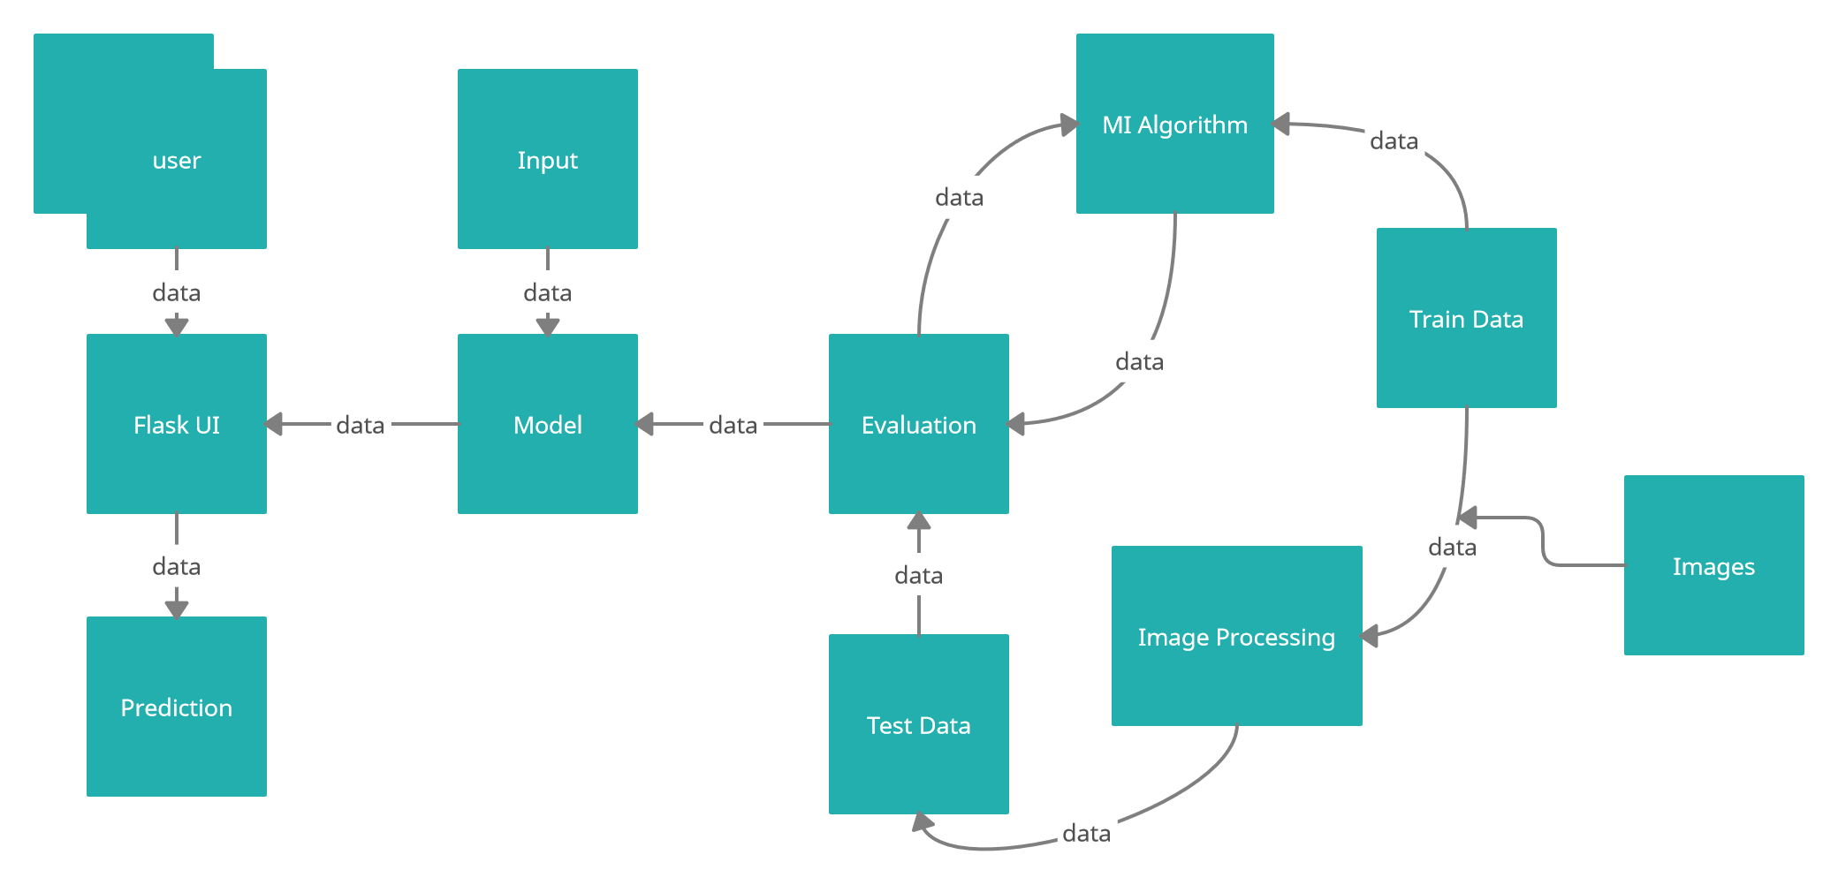

**User Stories**

Use the below template to list all the user stories for the product.

| **User Type** | **Functional Requirement (Epic)** | **User Story Number** | **User Story / Task** | **Acceptance criteria** | **Priority** | **Release** |
| --- | --- | --- | --- | --- | --- | --- |
| Customer | Uploading the real time data. | USN-1 | The user will be presented with two options.   1. Speech to sign language conversion. 2. Sign language to speech conversion. | They can access the portal | High | Sprint-1 |
|  |  | USN-2 | Language selection | They can access the portal | Low | Sprint-1 |
|  |  | USN-3 | The deaf-mute person will choose the speech to sign language conversion which would take them into a portal that collects the real time data (sign language recognition) and converts it into speech simultaneously. | Video processing | High | Sprint-2 |
|  |  | USN-4 | Emotion detection | Video processing | Medium | Sprint-1 |
|  |  | USN-5 | Normal person would choose speech to sign language which would take them into a portal where their speech is converted into sign language simultaneously. | Video and audio processing | High | Sprint-1 |